# Document History

The master version of this document is stored by TfL in the FTP TFS Source Control at; $/Deployment/Main/Documents.

Any version of this document not from this location is not controlled.

|  |  |  |  |
| --- | --- | --- | --- |
| **Date** | **Version** | **Changes** | **Changed By** |
| 10/06/2014 | 0.1 | Created | Nitin Chadha |
| 13/06/2014 | 0.2 | Modified | Nitin Chadha |
| 16/06/2014 | 1.0 | Modified & Released to Cubic | Nitin Chadha |
| 23/06/2014 | 1.1 | Minor change | Nitin Chadha |
| 10/10/2014 | 1.2 | Added Cleaning task for Config Audit table | Nitin Chadha |
| 06/10/2014 | 1.3 | Added Notes to stop cache host individually | Nitin Chadha |
| 27/01/2015 | 1.4 | Added cache usage script setup instruction | Nitin Chadha |
|  |  |  |  |

AppFabric Installation Guide for FAE Scale Environments

In the scale environments we are setting the AppFabric cache with **high availability**. Which means more than one copy of the data object would be stored in the cache. In an event of a cache host failure the secondary copies of the data would be made available to the client application via other non failed hoststo prevent the data loss.

Prerequisites

* Windows Server 2008 Enterprise or DataCenter Editions (Full GUI).Requires .NET 4.0
* AppFabric 1.1
* SQL Server Instance with alwayson for AppFabric cache host configuration and cluster management.
  + Service account –zsvcfae for FAE
  + domain\zsvcappfabserver (Need Run as service, run batch jobs, local admin)
  + domain\zsvcappfabbatch (Need Run as service, run batch jobs, local admin)
  + Create a new role ROLE-G-AppFabricClusterManagement and add zsvcappfabserver, zsvcappfabbatch and any other userswho would be using AppFabric cluster including starting and stopping the cluster and checking the cache statistics.
* The AppFabric Cluster, the database server and the server running the client application (e.g. pipelinehost.exe) has to be on the same domain.
* Note: For Customer experience only - the scripts resides in TFS at $/Deployment/Main/Code/Utilities/AF Monitoring

## Install the AppFabric caching software on the Hosts

### Install AppFabric Caching Software

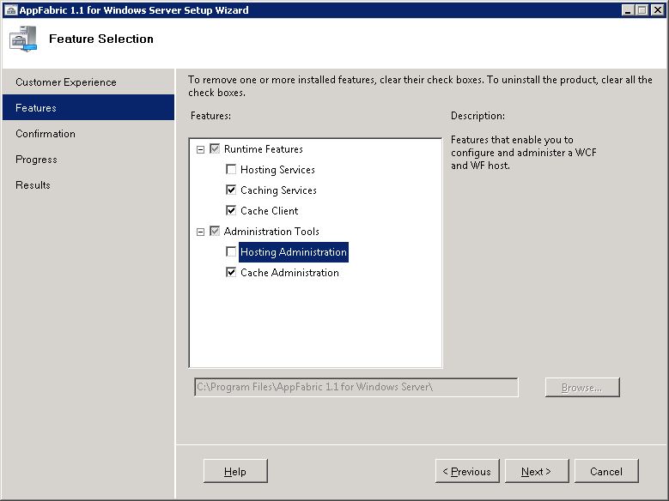

(Fig 1)

### Install cumulative rollup: <http://support.microsoft.com/kb/2716015/EN-US>O

## Setup the Database

To setup the AppFabric cache cluster to use SQL server as the cluster manager for high availability - it is recommended to use a high availability strategy, such as database clustering or mirroring, to keep the database available for cache cluster management responsibilities

TheSQL server database for AppFabric caching must be setup as an "alwayson" database.

### Connect to the "Availability Group Listener" using the SQL server manager e.g.AlwaysonAPF (Speak to your dba to get the Alwayson Availability Group Listener)

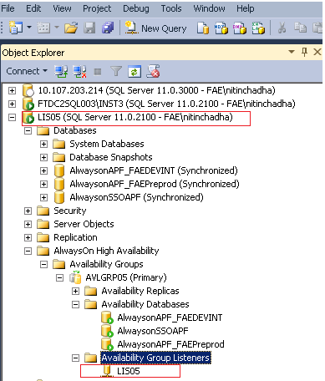

(Fig 2)

### Right click Databases and create new database. Assign the database name - APFConfig_FAE and click OK.

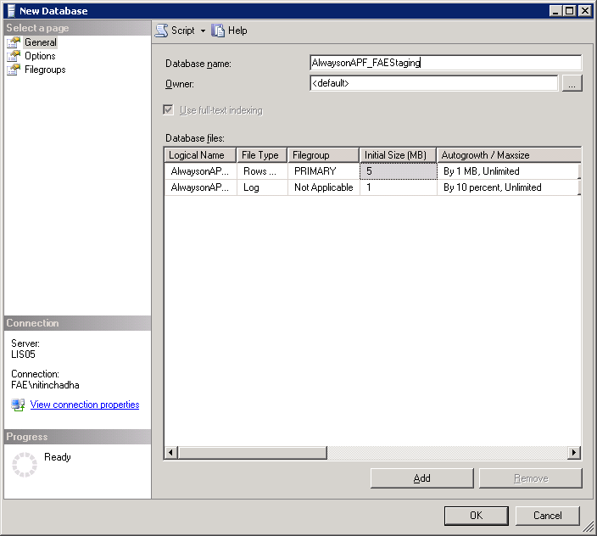

(Fig 3)

### Expand Security from the left pane on the Sql Server. Right click -> New Login Specify the role - ROLE-G-AppFabricClusterManagement created earlier and click ok C:\Users\NitinChadha\AppData\Local\Microsoft\Windows\Temporary Internet Files\Content.Word\alwasyon7.png

### Select "User Mapping". Select APFConfig_FAE and check db_datareader and db_datawriter from the list. Click OK.

### Right click the APFConfig_FAEdatabase. Click Permissions. Select the role ROLE-G-AppFabricClusterManagementand assign Execute permissions from the list below. Click OK.

### RDP/Login to one of the four AppFabric Host.

### Open Powershell ISE - (%windir%\system32\WindowsPowerShell\v1.0\PowerShell_ISE.exe)

### Open the attached script SQLClsutermanagersetup.ps1 in PowerShell_ISE and set the correct database name and the server.

# Set the database_name to the empty database created earlier#

$database_name= "**APFConfig_FAE**"

# Set the database_server to the alwayson database server#

$database_server= "**alwaysonAPF**"

### After making the above change. Run the script. Make sure the script execution output is all green.

## Configure the AppFabric caching software on the Hosts

### Locate Configure AppFabric in "All Programs" -> "AppFabric for Windows ServerSetup AppFabric server configuration

In the configure caching service pane. Check the set caching service checkbox.

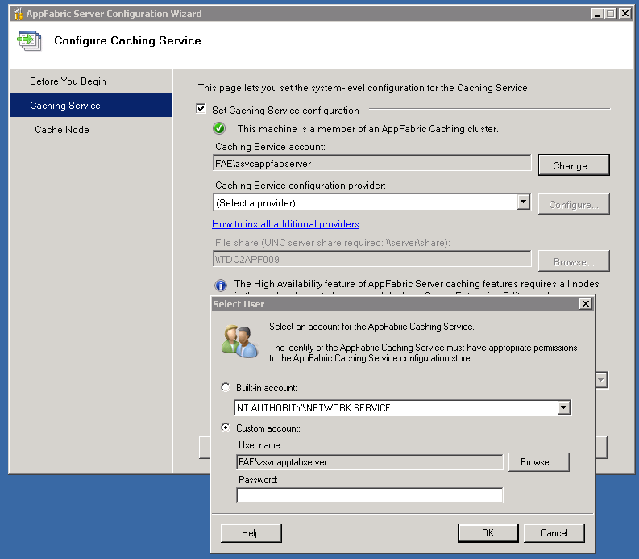

### In the caching service account change the service account to "<internal domain>\zsvcappfabserver"

### In the Caching service configuration provider - select SQL Server AppFabric Caching Service Configuration Store provider. Click Configure

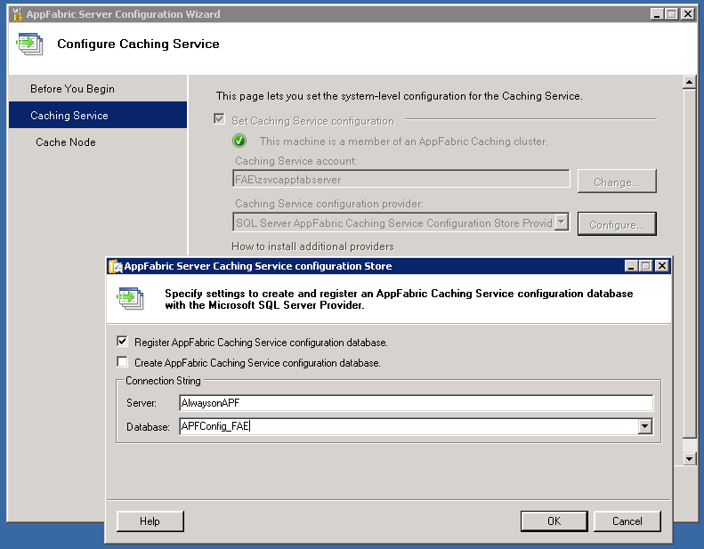

### Make sure "Register AppFabric Caching Service configuration database" is checked and

**Create** "AppFabric Caching Service Configuration database" is **unchecked**.

### In the Server field: type the Availability Group Listener" e.g. AlwaysonAPF which was setup earlier in step 1.2.1.

### In the database field: type APFConfig_FAE. Click OK

### Check "Join Cluster" radio button and click Next and then Finish.

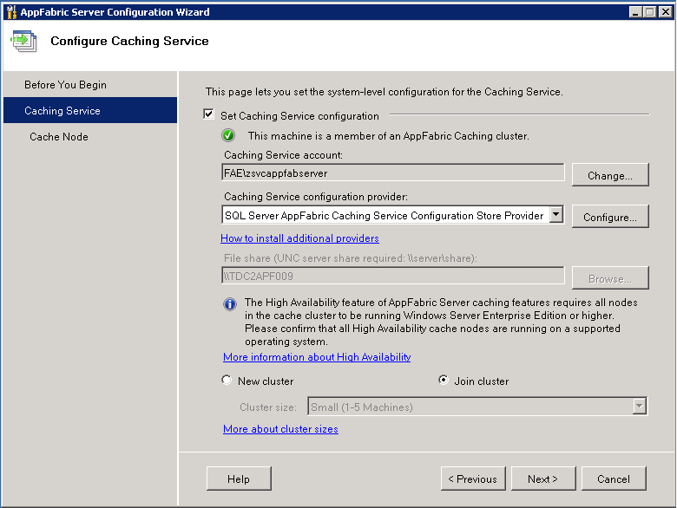

### Repeat the Steps from 1.1.1 to 1.1.2 and 1.3.1 to 1.3.7 for the other AppFabric Cache hosts.

## AF Cluster Administration

### On any AppFabric Cache host - Open “Caching Administration Windows PowerShell” in Start -> "All Programs" -> "AppFabric for Windows ServerSetup AppFabric server configuration

(In the hardened environments - Right click and open using "Run as administrator")

### Enter Start-CacheCluster

### Create new cache by using New-Cache FAEIntradayHA -Secondaries 1

### Grant <Internal domain>\zsvcfae the AF cache access. Grant-CacheAllowedClientAccount <Internal domain>\zsvcfae

## Setup APF Cache powershell monitoring scripts

### Open windows explorer Go to %System32\WindowsPowerShell\v1.0 and create a new folder. Name it "Custom".

### Copy AppFabServiceStatusCheckHA.ps1, StartApfabricHostOnServerBoot.ps1 and StopAppFabricHost.ps1 from \Scripts\Powershell\Monitoring to the folder created above.

### Run Powershell ISE - (%windir%\system32\WindowsPowerShell\v1.0\PowerShell_ISE.exe) (In the hardened environments - Right click and open using "Run as administrator")

### Open AppFabServiceStatusCheckHA.ps1

### In the customisable variable section,replace the following values as per your environment and needs. The "mail to" will receive status email alerts of AppFabric hosts in an event of a failure.

$servers = "APFCacheHost1","APFCacheHost2","APFCacheHost3","APFCacheHost4"   
 $mailTo = "email1@tfl.gov.uk","email2@tfl.gov.uk"  
 $mailFrom = "senderemail @tfl.gov.uk"  
 $smtpserver = "cubic.smtpserver.tfl.local"

### Open windows task scheduler. Import the three tasks.

Before clicking ok after each import, change the user to **internaldomain**\zsvcappfabbatch

### In the task scheduler library, make sure the newly imported three tasks are listed.

### Disable task StopAppFabricHost. This task is only used for server maintenance. Only to bring the cache host server down. Run this task to stop the AppFabric host before the shutdown or reboot.

### To test the Appfabric MonitoringHA task - from the Caching Administration Windows PowerShell - Run Stop-CacheHost <cachehostServername1> 22233

### From the task scheduler library, run Appfabric MonitoringHA and wait for the monitoring emails. The email would notify that cache host is down. it will try to start the cache host, the result of that attempt would also be shown in the email. (Sample email)

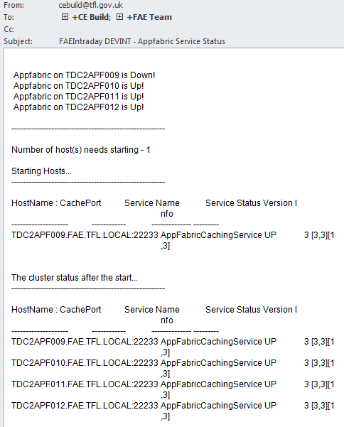

## Cleaning up High Availability ConfigAudit table

Setup a scheduled job in SQL Server to run every day with the statement mentioned below.

Delete from dbo.configaudit where UpdatedTimeStamp < getdate()- 3

## Monitoring AppFabric Cache Usage

**The job is needed for the TFL FTP team to monitor the FFAEIntradayHA cache for future planning and scaling.**The script needs to be setup in the task scheduler to run once a day before the cache expiry i.e. 4am. The result of the action would be emailed to list ($mailTo ) in the script. On the first of every month it would also attach the last monthly csv file with the email.

### Copy MonitorNReportAFCacheUsage.ps1 to %System32\WindowsPowerShell\v1.0\Custom on only one of the AppFabric Cache Host.

### Run Powershell ISE - (%windir%\system32\WindowsPowerShell\v1.0\PowerShell_ISE.exe) (In the hardened environments - Right click and open using "Run as administrator")

### Open MonitorNReportAFCacheUsage.ps1

### In the customisable variable section replace the following values as per your environment.

**Leave the** [**CEAPFMonitoring@tfl.gov.uk**](mailto:CEAPFMonitoring@tfl.gov.uk) **and add the other email addresses if you’d also like to receive the daily report.**

$mailTo = "CEAPFMonitoring@tfl.gov.uk ","email2@tfl.gov.uk"  
$mailFrom = "senderemail@tfl.gov.uk"  
$smtpserver = "cubic.smtpserver "

**LogFilePath only needs to be changed if the location needed to be different than the one mentioned below .  
$LogFilePath="D:\TFL\AppFabricCacheUsageLog\"**

### Important: Please make sure your SMTP server allows relaying to external email address.

The [CEAPFMonitoring@tfl.gov.uk](mailto:CEAPFMonitoring@tfl.gov.uk) needs to receive the daily email from this job.

### Open windows task scheduler. Import the task APF Cache Usage Monitoring.xml.

Change the user to **internaldomain**\zsvcappfabbatch and make sure in the security options – “Run whether user is logged on or not” **is selected**  and “Do not store is password **is not selected**”

### In the task scheduler library, make sure the newly imported task is listed.

### To test the APF Cache Usage Monitoring task, from the task scheduler library, right click and run APF Cache Usage Monitoring task and wait for the monitoring emails. Wait for a few minutes for the emails. (Sample email)

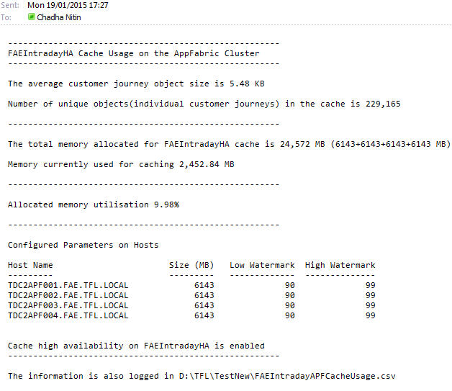

Basic tasks and Support

* To check if the cachecluster is up and running.  
    
  Run Get-CacheHost
* To Stop/Start the AppFabric Caching - Open powershell for AppFabric  
    
  Run Stop-CacheCluster or Start-CacheCluster

(Stop the Caching using the command above if you are permanently disabling the AppFabric caching)

* To Stop/Start the AppFabric Cache Host Individually (In a cache cluster make sure at least two host are running at a given time)  
    
  -Open powershell for AppFabric  
  Run Stop-CacheHost Host1 22233   
    
  -To Start the host

Start- CacheHost Host1 22233

* To check for number of items stored in the AppFabric Cache  
    
  Run Get-CacheStatistics FAEIntradayHA
* If you are installing AppFabric for the first time, make sure to install cumulative rollup afterwards: <http://support.microsoft.com/kb/2716015/EN-US>
* The service account which is being used to run the service must be setup on the DB with Read/Write and Execute on the same.
* Note: **DO NOT** Stop/Start the AppFabric caching host service from the Service Control Manager.